**Parallel Computing - Lab 06**

**IT23226128**

**Repository Link:** [**https://github.com/geethsenaviratne/IT23226128-Parallel-Computing-Labs-.git**](https://github.com/geethsenaviratne/IT23226128-Parallel-Computing-Labs-.git)

**Exercise 02**

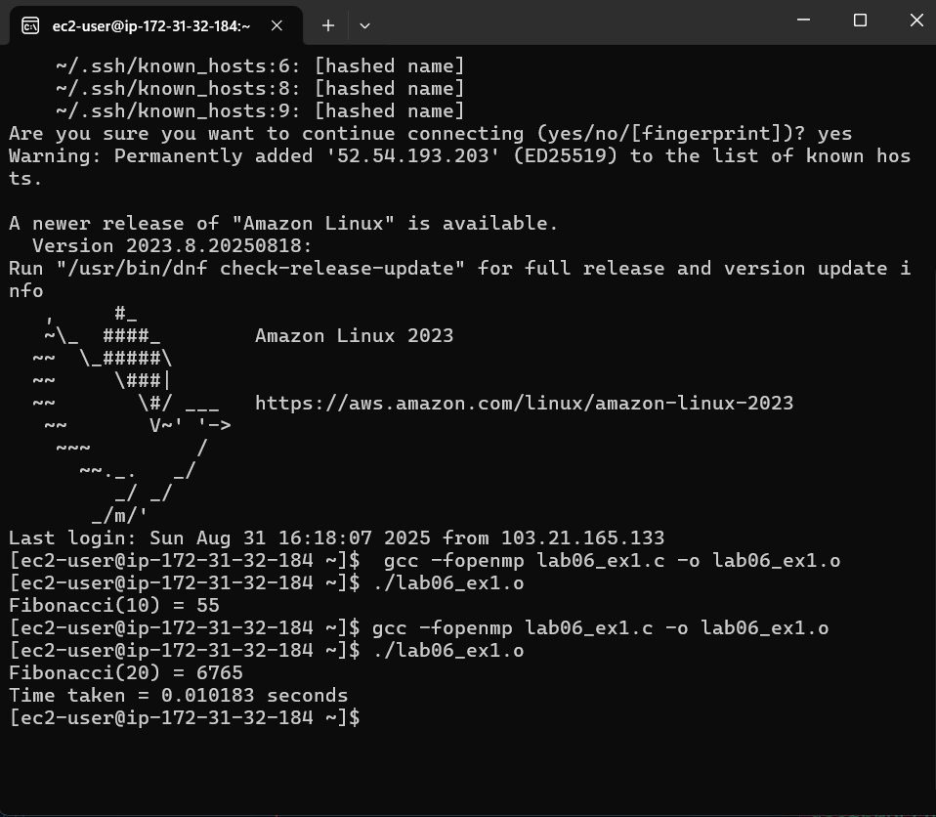

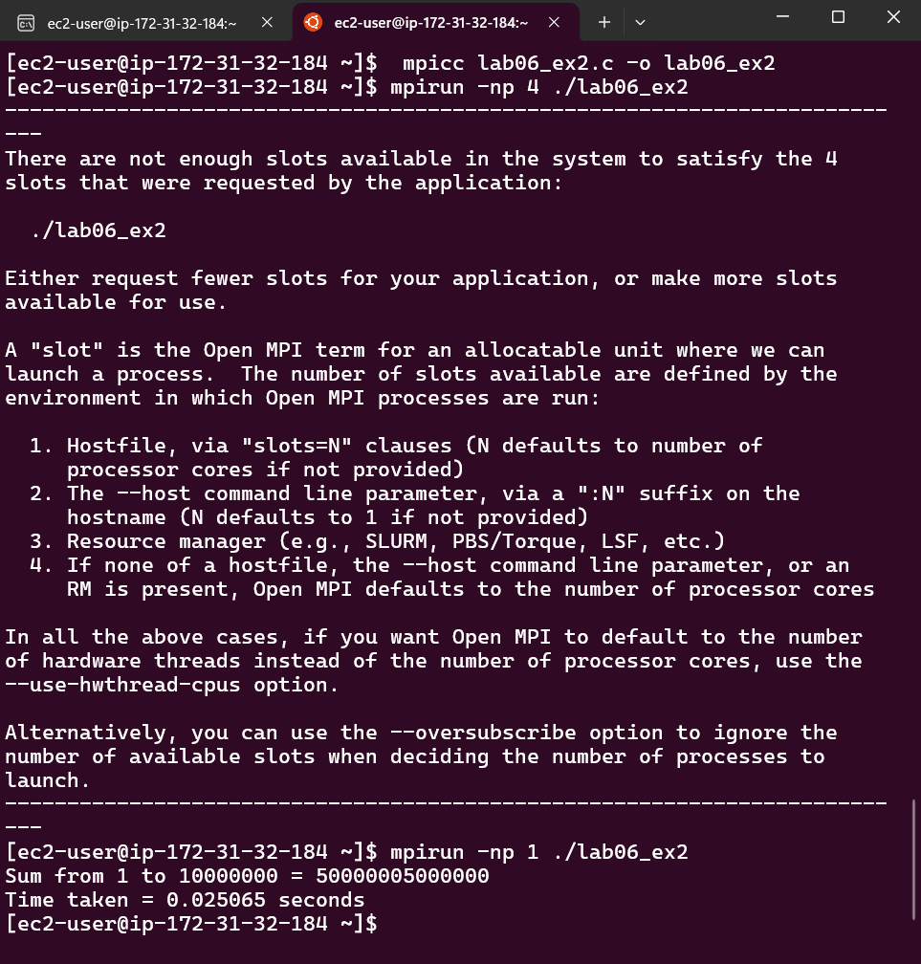**Exercise 03**

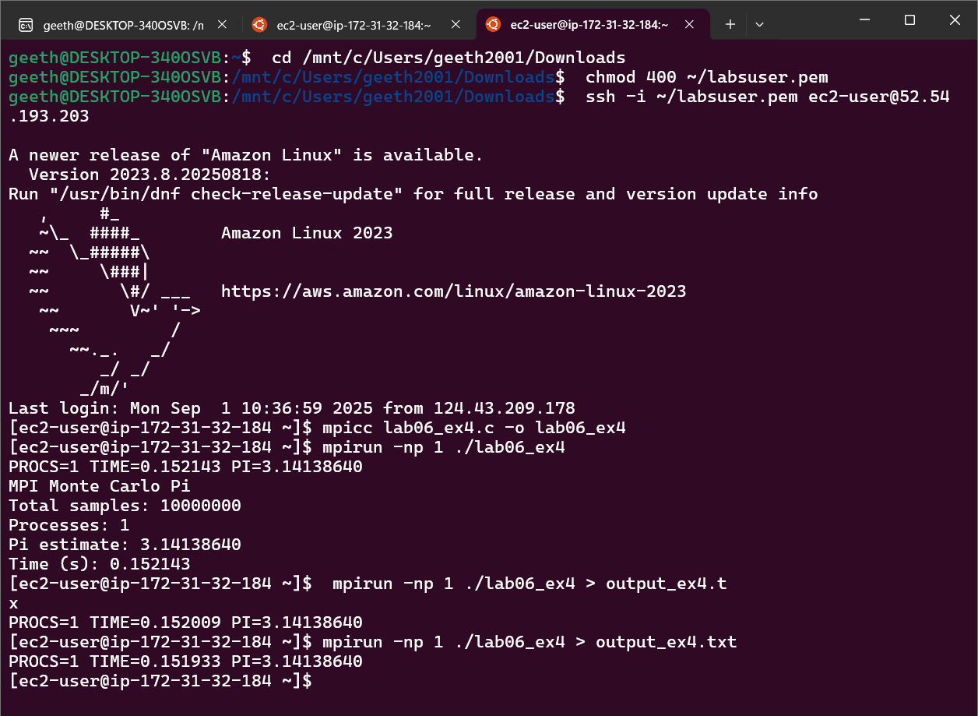**Exercise 04**

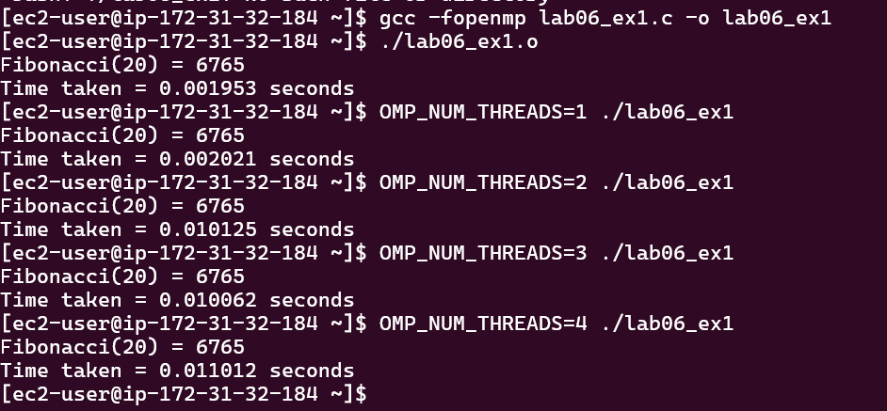**Exercise 05**

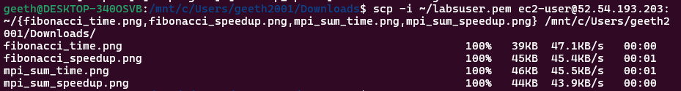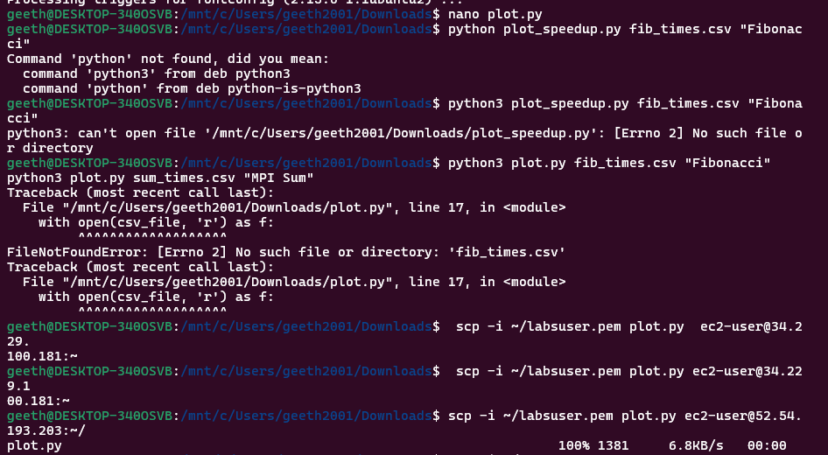

**Fibonacci Time**

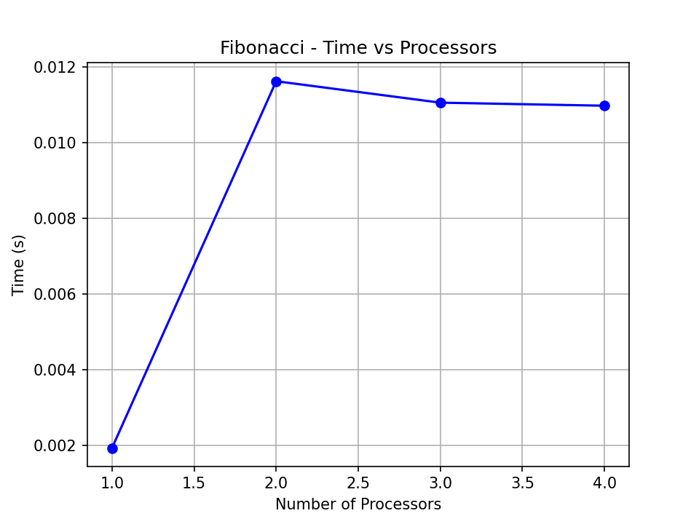

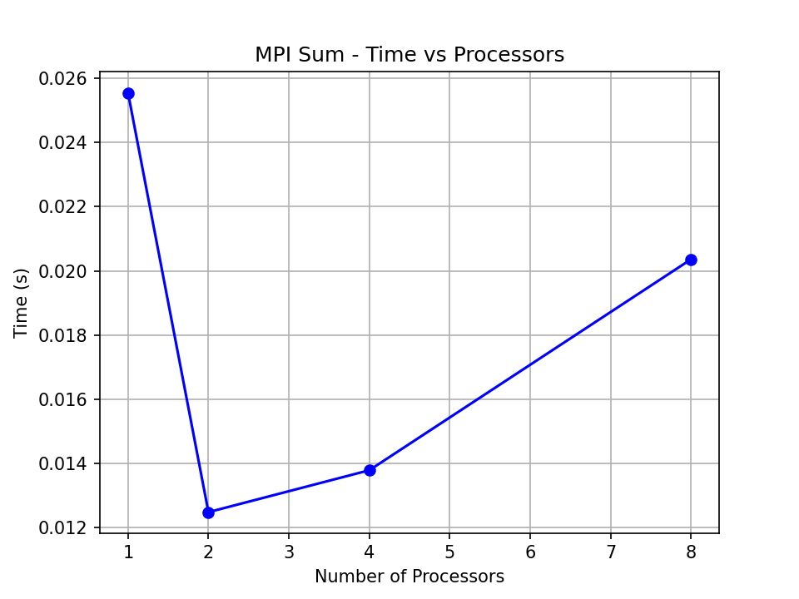**MPI sum time**

**Fibonacci Speedup**

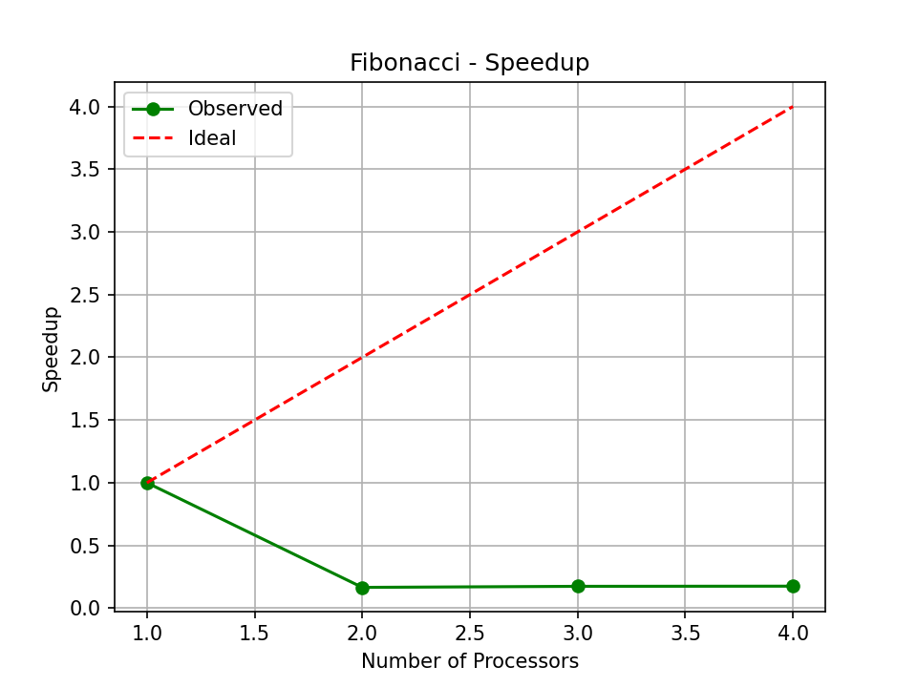

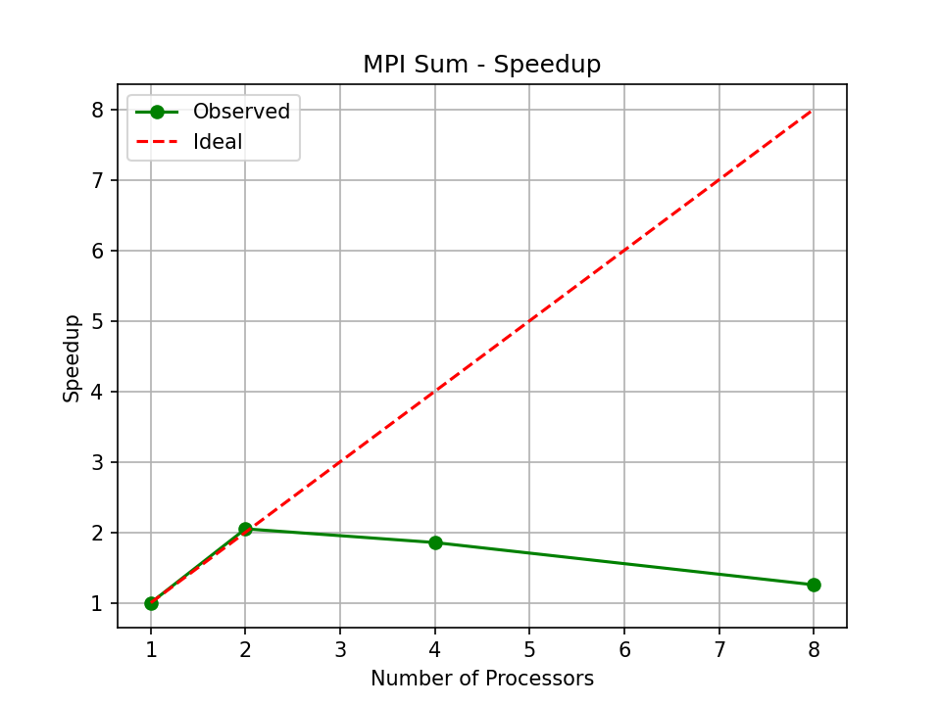**MPI Sum Speedup**

**Exercise 06**